# Calibration of the 3D Motion Analysis System and Force Platforms

1.0 Overview

1.1 Procedure general details

This procedure describes the motion capture system set-up, calibration and quality assurance tests carried out prior to patient assessments.

**1.2 Equipment used**

* T1650 workstation PC
* Vicon MX system with 8x T20-S infrared cameras and 2x Bonita video cameras.
* Two Force platforms/plates (OPT464508-HF-1000).
* Vicon Nexus software (version 2+).
* Vicon Active Wand.
* Three 10kg calibrated weights with trolley.
* Metal pole with retroreflective markers.

**1.3 Summary of procedure**

1. The force platform amplifiers are switched on.
2. The Vicon Giganet is switched on.
3. The T1650 workstation PC is switched on and the user logs in.
4. The Vicon Nexus software is loaded.
5. Nexus is put into Live mode.
6. Cameras and the Vicon Giganet are verified to be active and working.
7. Force platforms are added to the available hardware and zeroed.
8. A new calibration session is created for the current date.
9. Video cameras are switched to IR mode.
10. Camera masks are created.
11. Cameras are calibrated using the Active Wand.
12. The lab origin is set using the Active Wand.
13. A recording is made of calibrated weights being loaded onto the force platforms, recorded values are checked against expected ranges.
14. A recording is made of the marker-equipped pole being repeatedly pressed against the force platforms, recorded values are checked against expected ranges.

**1.4 Document conventions**

Where this document specifies an element within Microsoft Windows or the Vicon Nexus program such as a pane, button or tab, it will be highlighted in blue, e.g., Data Manager.

**2.0 Motion capture system calibration procedure** (CMAS: System Orientation)

**2.1 Starting the motion capture system**

1. Switch on the Force platform amplifiers, both switches should be illuminated as shown in Figure 1(A1 & A2).
2. Switch on the Vicon Giganet, the switch is located on the back of the device; the position is indicated by the “POWER ->” label. See Figure 1(B) and Figure 2(A).
3. Power on the T1650 workstation PC and log in.
4. Start the Vicon Nexus program (version 2.9.2 or later) from the Start Menu or Desktop icon.

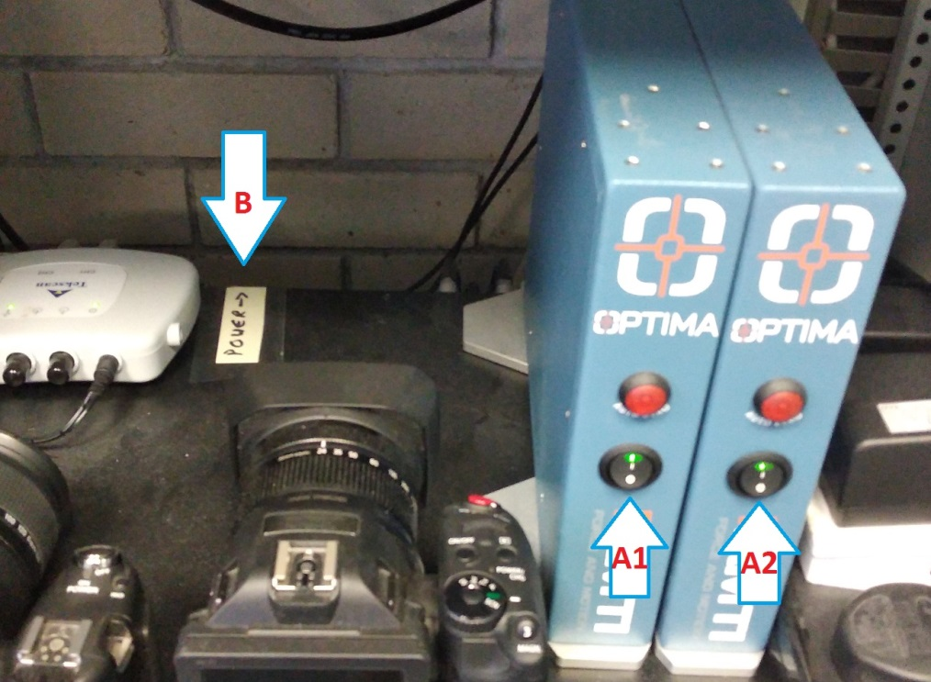

**Figure 1: Force plate amplifier power switches (A1 & A2). Vicon Giganet power switch is located on the back of device (B).**

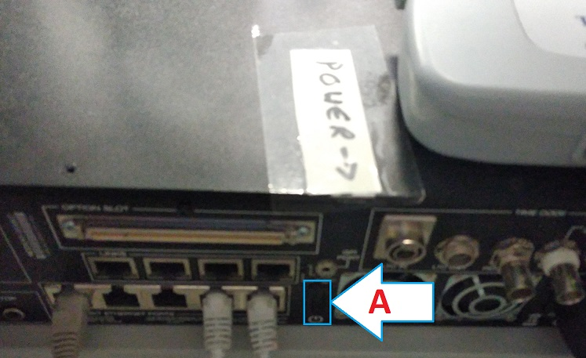

**Figure 2: Location of the Vicon Giganet power switch (A) on the rear panel of the Giganet.**

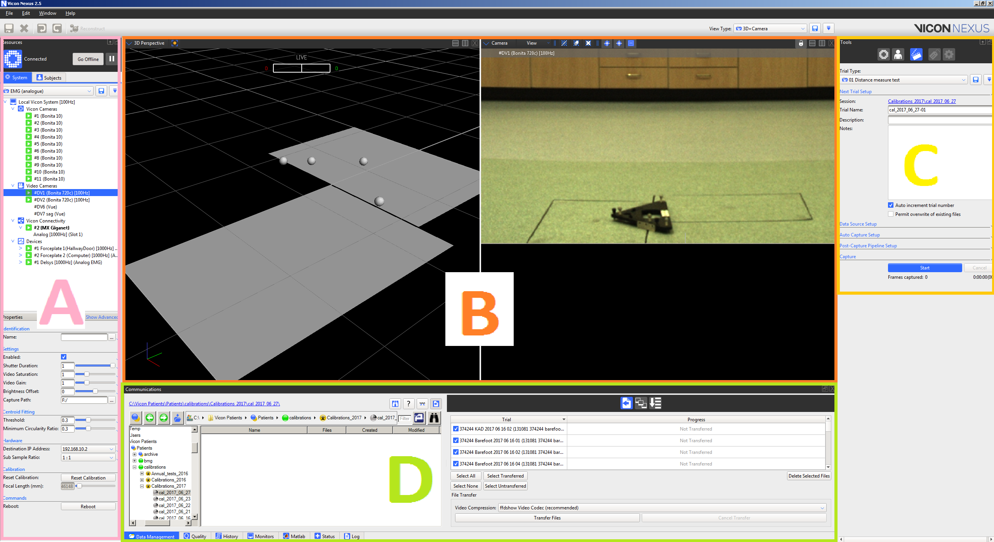

**Figure 3: Screenshot of the Vicon Nexus program showing A The Resources pane; B configurable combinations of 3D, camera(s) and graph views; C the Tools pane and D The Communications pane. Note that the Communications pane may be hidden or in a separate window; press the F2 key on the keyboard to display it.**

**2.2 Configuring Nexus to add Force Platforms**

The lab force platforms will not be present in the hardware configuration of Nexus when it is first initialised, follow this procedure to add the platforms.

1. Click the Go Live button in the top-right of the Resources pane (Figure 3A); this button will then toggle to Go Offline (Figure 4,A). Ensure that the MPH2018_MM hardware configuration is active (Figure 4,B)
2. Verify that all devices are working; there should be a green “play” icon beside all of the Vicon cameras, the Video Cameras and Vicon Connectivity; see Figure 5.
3. Right-clicking the Devices (Figure 5A) section presents a menu (Figure 5B) where AMTI Optima devices can be added from the Add Digital Device options (Figure 5C).
4. After adding the force platforms, zero them by right clicking AMTI Digital device common settings (Figure 6A) then selecting Zero digital platforms from the pop-up menu (Figure 6B).
5. Changing the View Type to Calibration View presents a real-time view of each of the cameras. Moving a marker through the capture volume and stepping on the force platforms while viewing the screen will verify the basic functionality of these devices.

|  |  |
| --- | --- |
| **Figure 4: The Go Live / Go Offline button (A). The hardware configuration drop-down list (B).** | **Figure 5: Adding force platforms to the current hardware configuration. Right clicking the Devices (A) section presents a menu (B) where AMTI Optima devices can be added from the Add Digital Device options (C).** |

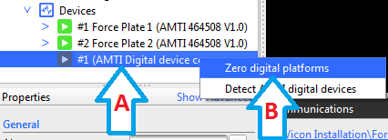

**Figure 6: Right clicking the Digital device common settings (A) presents the option to Zero digital platforms (B).**

**2.3 Camera Calibration, Definition of Lab Coordinate System and Force Platform Position**

1. Click the Calibration button (Figure 7A) in the Tools pane (Figure 3D).
2. Click Activate to put the video cameras into calibration mode (Figure 8A), this button will toggle to a Deactivate button.
3. Ensure that all retroreflective markers are out of view of the cameras.
4. Click Start (Figure 8B) to automatically create camera masks, the Start button will toggle to a Stop button; inspect each of the camera views to verify all visible sources of infrared light (shown in white) are covered in blue masks.
5. Click Stop.
6. Under Calibrate Cameras click Start (Figure 8C) to initiate camera calibration. Ensure that the Active Wand is NOT ON.
7. For best results position yourself around two meters in front of the coronal video camera facing the camera. Switch the Active Wand on and walk backwards along the lab moving the Wand in large circles. Thereafter walk through the calibration volume ensuring that the LEDs on the Wand are visible to each camera. Each of the IR cameras with the exception of camera 6 has a flashing blue indicator on the front; when a camera gathers enough data points the indicator will change to solid blue.
8. Nexus will calculate image and world errors and present them at the bottom of the calibration tools. If any of the values exceed the limits they will be shown in red, the system can be recalibrated if necessary to fix this issue.
9. Under the Video Calibration Setup section click Deactivate to return the video cameras to video mode (Figure 8A).
10. To define the lab coordinate system, place the Active Wand on the force platforms as shown in Figure 9. If necessary, adjust the thumbwheels on the wand to centre the bubble-levels.
11. Click Start (Figure 8D) to identify the wand, the button label will then change to Set Origin; press the button again to define the lab origin. If this step fails ensure that the cameras are deactivated as described by 2.3.9 then click Start then Set Origin again.

|  |  |
| --- | --- |
| **Figure 7: The Tools pane showing the Calibration (A), Subject (B), Capture (C), Labelling (D) and Pipeline (E) buttons.** | **Figure 8: Calibration tools in the Tools pane.** |

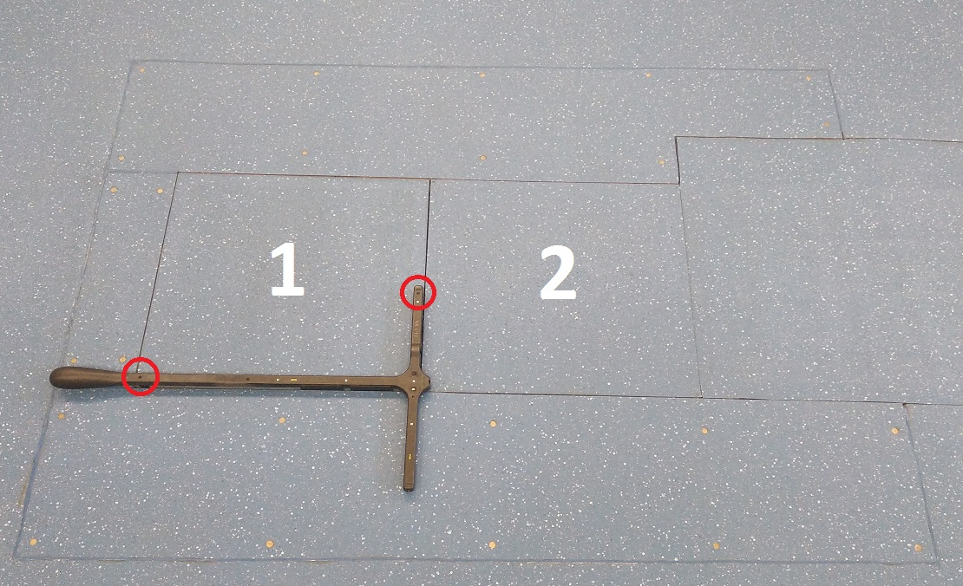

**Figure 9: The Active Wand placed on the force platforms. Platform 1 is closest to the lab entrance. The red circles indicate the positions of the thumbwheels that level the Wand.**

**3.0 Quality Assurance Tests** (CMAS: System checks)

Summary: Two tests are carried out to ensure the data provided by the gait analysis system meets the required specifications. The first determines the measurement accuracy of the force platforms by using three calibrated 10kg weights to incrementally load then unload them. The second uses a rigid, metal pole to load each force platform at a minimum of three points; the position of the point of force application as measured by the motion capture system and the force platforms is then compared to verify how well they correlate.

SAFETY NOTE: Moving the 10kg weights poses a risk to the handler. Please ensure that you have carried out a risk assessment prior to carrying out the test.

**3.1 Force Platform Fz Measurement Accuracy**

1. In the Communications pane (Figure 3,D) ensure that the Data Management tab is active (Figure 10,A) then navigate to D:\Forceplates\Calibrations 20XX (where XX is the current year) as shown in Figure 10,B.
2. Click the new session button (Figure 10,C). Name the session with the current date in the format YYYY-MM-DD then double-click the new session to make it active.
3. Click Go Live (Figure 4,A) in the Resources pane if the system is not already live.
4. From the System Tab in the Resources pane select the MPH_FP_TEST hardware configuration (Figure 4,B).

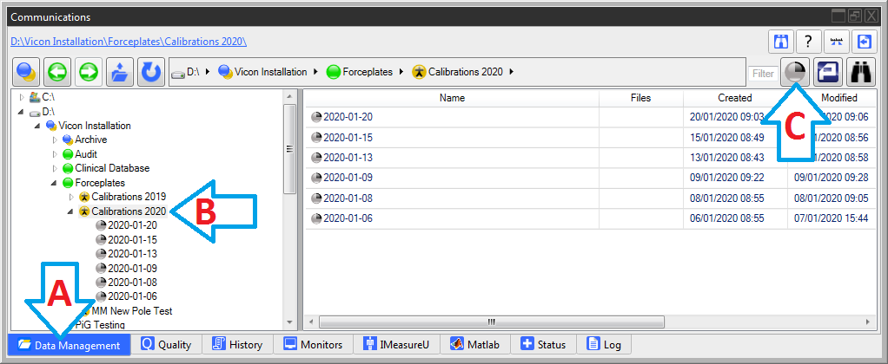

**Figure 10: The Communications pane. Data management is the currently active tab (A). The calibration folder for the current year is shown in the left pane (B). The create new session button is indicated by C.**

1. In the Tools pane click the Capture icon (Figure 11,A) then select 01 FP weight test Trial Type (Figure 11,B).
2. 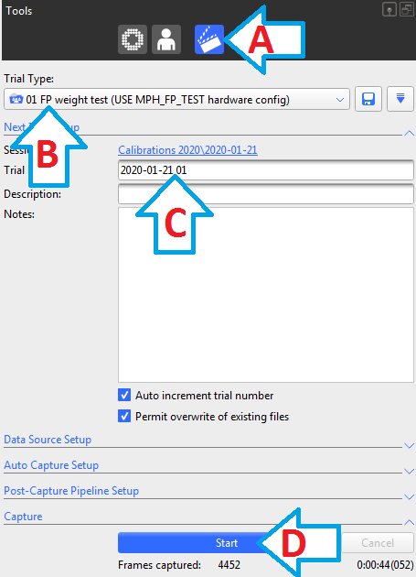Move the cart carrying weights alongside the FP’s and place weights on floor beside the platform as illustrated in Figure 12(1).
3. Zero the force platforms as shown in Figure 5.
4. Edit the trial name – put a space between trial name and the last two numbers, i.e., YYYY-MM-DDNN becomes YYYY-MM-DD NN (Figure 11C)
5. Start the recording (Figure 11D).
6. Move the weights between the force platforms as illustrated by Figure 12(2,3,4). Leave at least one second between moving each weight.
7. Click Stop recording (Figure 11D).
8. Double click the recorded trial to open it.
9. Select fp_test_graphs from the View Type drop-down list to view a graph of Fz values on each force platform. Inspect the values at each of the graph sections identified in Figure 13.
10. Check measured values against expected ranges defined in Table 1.

|  |
| --- |
| **Figure 11: Setting up a trial in the Tools pane. (A) the Capture icon. (B) the Trial Type. (C) the corrected trial name. (D) the trial Start recording/Stop recording button.** |

|  |  |
| --- | --- |
| **1** | **2** |
| **3** | **4** |

**Figure 12: (1) placement of the weights prior to the test before sliding them sequentially onto the force platform. (2, 3, 4) sliding the weights between, then off, the force platforms.**

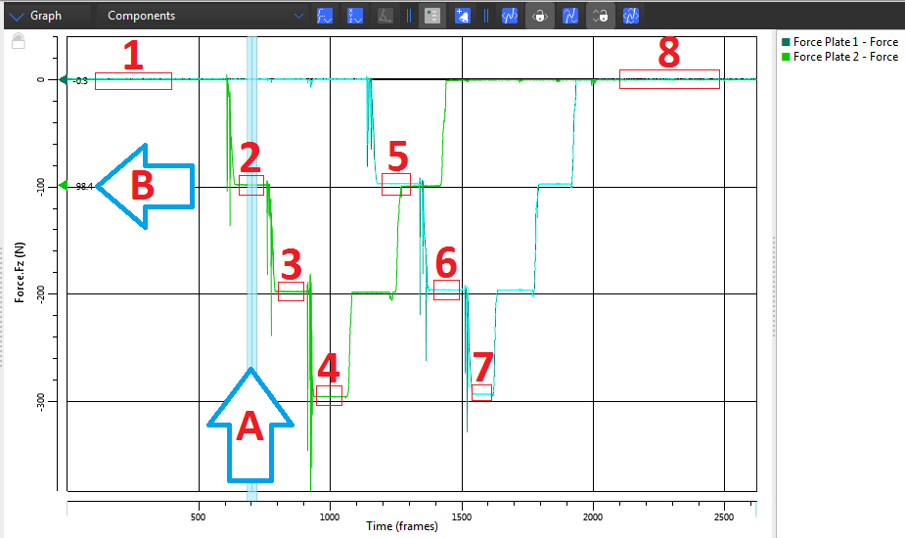

**Figure 13: Graph of force platforms Fz. The current frame can be changed by dragging the moveable bar A. The value at that frame is shown at B. Sections of the graph where Fz values should be inspected are highlighted in boxes 1 through 8.**

**Table 1: Force platform measurement upper and lower limits (±5%)**

|  |  |  |  |  |
| --- | --- | --- | --- | --- |
| g = -9.81ms-2 | Mass (kg) | Weight (N) | Lower limit (N) (-5%) | Upper limit (N) (+5%) |
|  | 10 | -98.1 | -93.2 | -103.0 |
|  | 20 | -196.2 | -186.4 | -206.0 |
|  | 30 | -294.3 | -279.6 | -309.0 |

**3.2 Motion Capture System & Force Platform measurement correlation (Pole Test)**

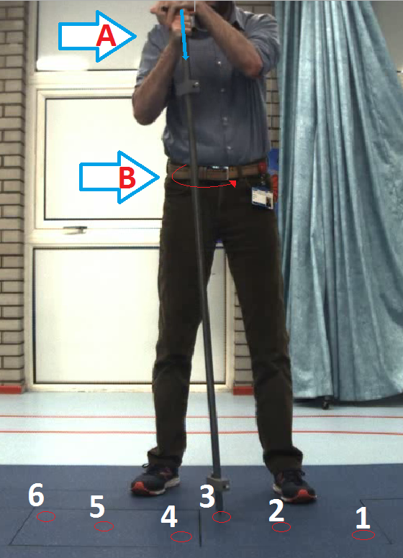

1. Click Go Live (Figure 4,A) in the System pane.
2. Select MPH2018_MM from the list of hardware configurations (Figure 4,B).
3. Select 02 FP Pole test from the Trial Type list.
4. Zero the force platforms as shown in Figure 5.
5. Start the recording (Figure 11D).
6. Place the point of the pole on the force platform (see Figure 14 points 1 through 6) for example test locations.
7. Apply force directly through the length of the pole (Figure 14,A) and move the pole in circles (Figure 14,B).
8. Repeat step 7 on at least three different locations for each of the platforms.
9. Click Stop recording (Figure 11D).
10. A spreadsheet will be automatically generated stating if the test passes or fails (Figure 15).

|  |  |
| --- | --- |
|  | **Figure 14: Pole test showing the direction of applied force (A); how the pole should be rotated (B); and suggested points (1 - 6) where the point of the pole should be applied to each force platform.** |

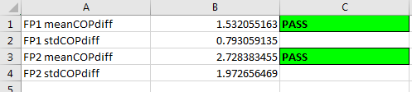

**Figure 15: Example output of the mean COP differences between the pole point and the COP as measured by the force platform.**

**3.3 Pass/Fail criteria for quality assurance tests**

* Force platform Fz tests are passed if the measured values fall within ±5% of the expected values.
* Pole test mean COP differences should be 5mm or less.

Reasons for the force platform Fz testing to fail are:

* 1. The wrong hardware configuration used (See 3.1.4).
  2. The platforms not zeroed prior to the test (See 3.1.7).
  3. Something was on a force platform, e.g., the wand, when it was zeroed introducing an artificial offset.

Reasons for the pole test to fail are:

* 1. Marker(s) not visible during the test.
  2. Insufficient force applied through the pole to the platform (minimum is 5kg).
  3. A moment measured by the platform as a result of the force not being applied directly down the length of the pole.
  4. Erroneous lab origin or lab orientation as a result of the wand being offset or skewed during the system setup procedure (See 2.3.10).

**4.0 Biannual system tests** (CMAS: Calibration)

Overview: Every six months static and dynamic measurements of a marker-equipped rig must be carried out. A more comprehensive pole-test is also carried out.

**4.1 Static measurement** (CMAS: absolute position of static markers in capture volume)

1. Click Go Live (Figure 4,A) in the System pane.
2. Select MPH2018_MM from the list of hardware configurations (Figure 4,B).
3. Select 99a L-Frame measurement test from the Trial Type list.
4. Name the trial Marker_measurement_test_YYYY-MM-DD STATIC TEST 01
5. Place the calibration object (Figure 16) on the force platforms.
6. Start the recording (Figure 11D), record at least ten seconds of data.
7. Click Stop recording (Figure 11D).
8. Inspect the automatically generated spreadsheet to determine if the test was passed.

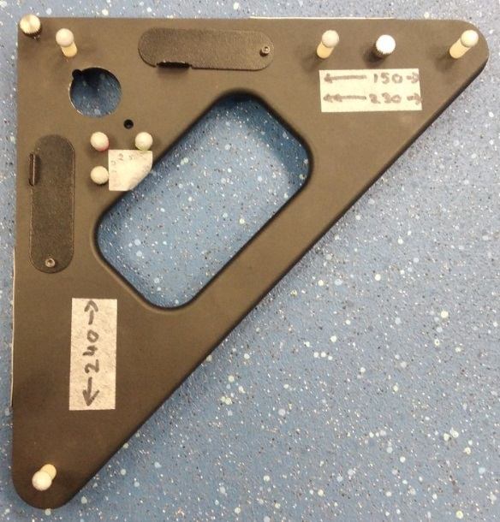

**Figure 16: The test object with marked distances between markers.**

**4.2 Dynamic measurement** (CMAS: relative marker position in capture volume during a dynamic test)

1. Click Go Live (Figure 4,A) in the System pane.
2. Select MPH2018_MM from the list of hardware configurations (Figure 4,B).
3. Select 99a L-Frame measurement test from the Trial Type list.
4. Name the trial Marker_measurement_test_YYYY-MM-DD DYNAMIC TEST 02
5. Start the recording (Figure 11D).
6. Move the calibration object (Figure 16) through the measurement volume ensuring markers are not obscured.
7. Click Stop recording (Figure 11D).
8. Inspect the automatically generated spreadsheet to determine if the test was passed.

**4.3 Biannual test pass/fail criteria**

* Static marker measurements should not present positional deviations of greater than 1mm.
* Dynamic measurements between markers should not exceed 5mm in the measurement volume.

**5.0 Data storage locations**

System orientation tests are first recorded to the T1650 Workstation PC then copied to the Trust network drive:

\\belnas04\image01\GAIT_Lab\Vicon Network Data\Vicon Installation\Forceplates

Biannual system test output is first recorded to the T1650 Workstation PC then copied to the Trust network drive:

\\belnas04\image01\GAIT_Lab\Vicon Network Data\Vicon Installation\Audit

An additional copy of the generated spreadsheets from the biannual tests is saved to:

\\BELBCHNAS01.belfasttrust.local\shared\ACUTE\TOON_Outpats\S_GaitAnalysis\Gait Analysis Files\Gait Analysis Management Documents\7 Equipment\VICON Equipment checks

**Previous and Current Document Summary**

|  |  |  |  |  |  |
| --- | --- | --- | --- | --- | --- |
| ***VICON Data Calibration Protocol*** | | | | | |
| **Version Number:** | **Author:** | **Date changes made** | **Date Approved** | **Next Review Due:** | **Comments** |
| Prior to v4.0 | **Jose Salazar (JS)** | N/A | N/A | N/A | Original standards were written by JS and are available on the gait lab server: :  *VICON Protocol v3* |
| v4.0 | MM | 07/02/20 | 07/02/20 (BMcD) | 07/02/2020 | Protocol rewritten by Martin Molloy |

BMD – Brona McDowell; MM – Martin Molloy; LH – Lee Humphreys